Team Project 1B

Adding Two Polynomials

Andrew Lange, Mason Johnson, Matt Hays, Steven Valet

**Design Explanation**

The system is separated into a Menu, Polynomial, and Term class. When the program is started, the Menu class loads and offers the user 4 options: Enter polynomial 1, enter polynomial 2, combine the 2 existing polynomials, or quit the program. If the user chooses to enter a polynomial, they are prompted to enter a string. That string is then broken up into individual characters as a linked list in the Polynomial class, where it first checks to make sure a valid expression was entered. If a valid expression was entered, the linked list is run through character-by-character and separated into a Term class that is defined by its coefficient, exponent, and variable (if any). Those terms of the polynomial are then sorted in descending order based on their exponent, and similar terms are combined (if they exist), and then they are pieced back together as a new linked list of characters. If the user chooses to combine polynomials 1 and 2 from the menu, then both polynomial linked lists are combined as a single polynomial linked list of characters. From there, that list is sorted and combined just like the original list, and the result is output to the console. The last option of the menu closes the program.

UML Chart Diagram

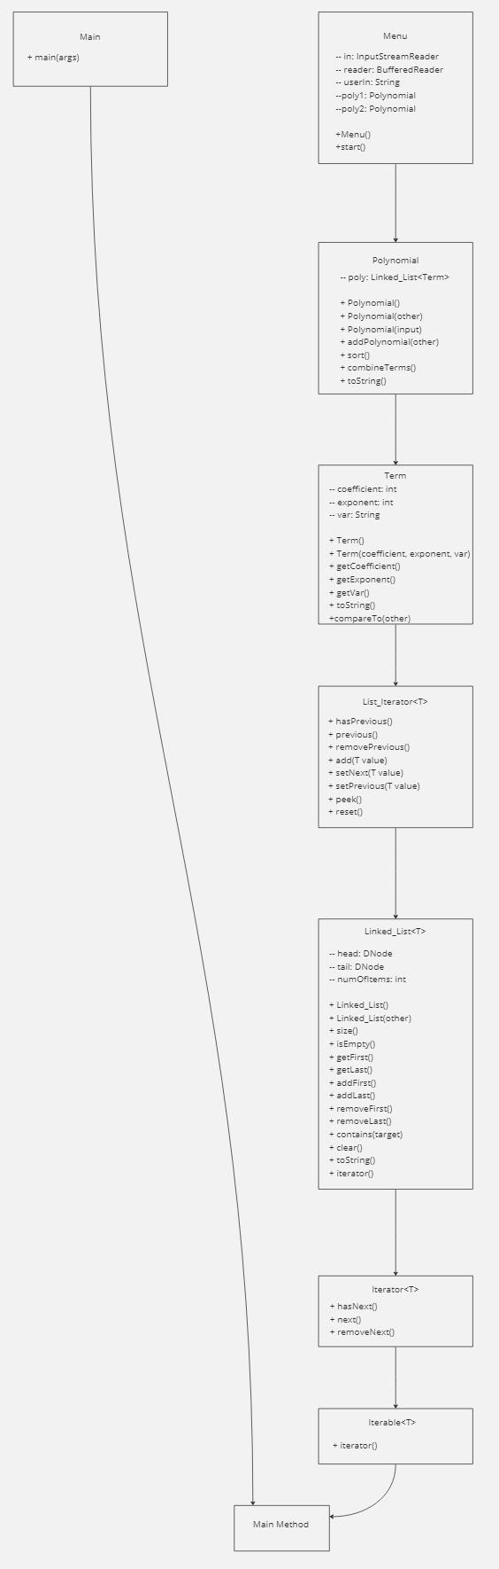

**Test cases**

Test case 1:

3x^3+3x^2+5x+1 + 2x^3-4x^2+3x+7

Menu options: 1, 2, 3, q

Expected result:

5x^3-x^2+8x+8

Actual result:

5x^3-x^2+8x+8

Test case 2:

-2x^2+6x-1 + 7x^4+x^3-5x^2+8x+9

Menu options: 1, 2, 3, q

Expected result:

7x^4+x^3-7x^2+14x+8

Actual result:

7x^4+1x^3-7x^2+14x+8

**Team Member Contributions**

**Andrew Lange -** Term.java fixes; UML Diagram

**Mason Johnson -** Polynomial.java assistance and fixes; Design explanation.

**Matt Hays -** Started repository, wrote foundation of Polynomial.java and Term.java.

**Steven Valet -** Split main.java into Menu.java, started Menu.java, started project report, project report pages 4 and 6

**Future Improvements**

In the future the addition of further mathematical operations could be implemented to allow for subtraction, multiplication, and division. One could also add functionality for fixing user input. For example, removing spaces, combining like terms prior to executing an operation, and changing excess variables to a single variable. The allowance of more than one variable could also be added to the functionality. Furthermore a menu option could be added to allow the user to enter a value for variables, along with calculating the result with said values.